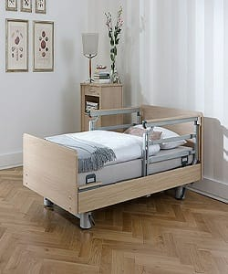

Hospital bed

$189.54

Availability: In stock

**Description:**

Highest hospital-related standards bed with column system is designed with a lavish modern style in premium linen upholstery. steel and additional metal legs to ensure stability and support.